 | 3rd international fair of transport technologies  and services  15th-16th September 2021 | Hotel “Jugoslavija”  Bulevar Nikole Tesle 3 11000 Belgrade,  Republic of Serbia
APPLICATION
Deadline for applications: 28-07-2021

Company |  |  | Filed under letter

# of employees |  | 2019 Annual Turnover (in EUR)

Basic products or services

Street/PO Box

Country / City |  | Zip Code

Tel (including area code) |  | Fax (including area code)

E-mail |  | Homepage

Contact person |  | E-mail

Contact person / accounting |  | E-mail

Legal Representative
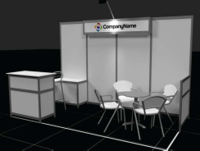
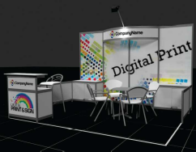

X
Desired stand (mark desired choice with): Stand with basic equipment Possibility with branding

Hall stand  m² front x depth |  | Hall stand  m² front x depth |  | Hallway stand  m² front x depth
12 | 4 x 3 m | 8 | 4 x 2 m | 8 | 4 x 2 m
Price for RCSEE members:  EUR 1050,00 |  | Price for RCSEE members:  EUR 890,00 |  | Price for RCSEE members:  EUR 820,00
Price for non-members:  EUR 1.280,00 |  | Price for non-members:  EUR 1100,00 |  | Price for non-members:  EUR 1020,00
Sponsor: Plat Gold Silver |  | Sponsor: Silver |  | Sponsor: Silver
✓ We are familiar with and accept all Terms and Conditions for the exhibitors.

--------------------------------------------------------- --------------------------------------------------------------
Place, date Legally binding signature, company stamp

